Кафедра вычислительной техники

Программирование

**Лабораторная работа №4**

**Вариант** **33692.5**

Преподаватель: Горбунов Михаил Витальевич

Выполнил: Ву Минь Хиеу

Р3133

Санкт-Петербург

2021

**Diagram**

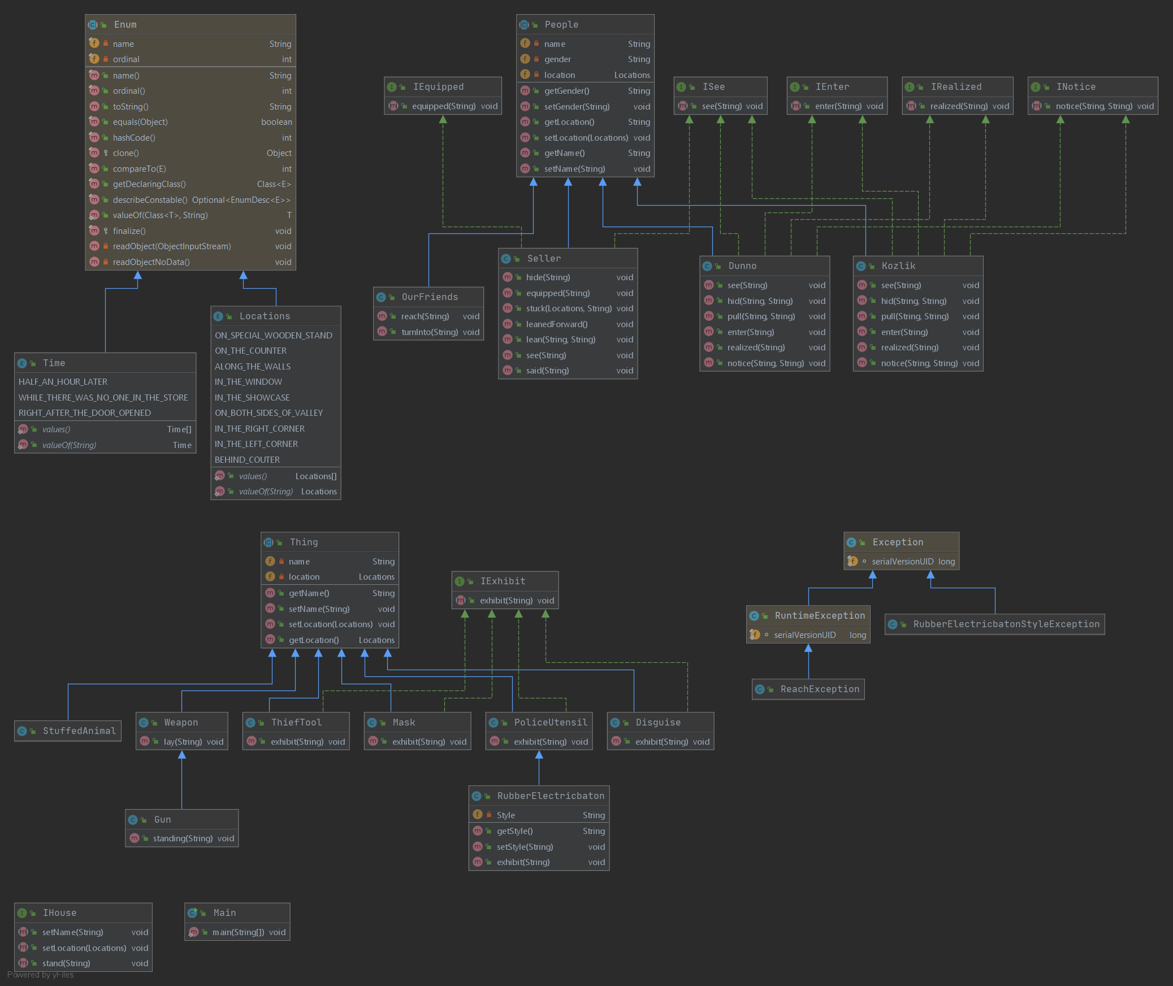

**Output**

Starting Gradle Daemon...

Gradle Daemon started in 1 s 142 ms

> Task :compileJava UP-TO-DATE

> Task :processResources NO-SOURCE

> Task :classes UP-TO-DATE

> Task :Main.main()

Dunno hid the letter back in his hat.

Dunno pulled the hattighter over his head.

Haft an hour later, Our friends reached Kruchenaya Street.

Our friends turned into a narrow alley, twisting like a snake among tall buildings.

The houses on both sides of valley standing so close together that the rays of light were lost in the upper floors, which left a mysterious twilight below, where numerous shops were located.

Dunno saw a sign over the door of one of the shops with the inscription "Sale of various goods".

Kozlik saw a sign over the door of one of the shops with the inscription "Sale of various goods".

Dunno entered the store.

Kozlik entered the store.

Dunno realized what kind of goods were sold here.

Kozlik realized what kind of goods were sold here.

Guns is standing in orderly rows, on special wooden stand

Pistol is laying in exemplary order, on the counter

Knives is laying in exemplary order, on the counter

Finks is laying in exemplary order, on the counter

Daggers is laying in exemplary order, on the counter

Brushes is laying in exemplary order, on the counter

Brass knuckles is laying in exemplary order, on the counter

Masterkeys is on display in the showcases illuminated from the inside, along the walls

Steelfiles is on display in the showcases illuminated from the inside, along the walls

Drills is on display in the showcases illuminated from the inside, along the walls

Pliers is on display in the showcases illuminated from the inside, along the walls

Nippers is on display in the showcases illuminated from the inside, along the walls

Crowbars is on display in the showcases illuminated from the inside, along the walls

Crowbars for breaking locks is on display in the showcases illuminated from the inside, along the walls

Autogenous machines for cutting fireproof cabinets is on display in the showcases illuminated from the inside, along the walls

Chests is on display in the showcases illuminated from the inside, along the walls

Set rubber electricbaton's style is a lot of style

Rubber electric batons is on display above which there was the inscription "Police Utensils", in the window

Steel handcuffs is on display above which there was the inscription "Police Utensils", in the window

Shackles is on display above which there was the inscription "Police Utensils", in the window

Incendiary bombs is on display above which there was the inscription "Police Utensils", in the window

Tear bomb is on display above which there was the inscription "Police Utensils", in the window

Other police items is on display above which there was the inscription "Police Utensils", in the window

Half face mask is on display in the showcase

Eye mask is on display in the showcase

Full face mask is on display in the showcase

Makeup is on display in the showcase

Wigs is on display in the showcase

Fake beards is on display in the showcase

Mustaches is on display in the showcase

In the right corner, Stuffed policeman is quipped full uniform, a shiny brass helmet on his head, a truncheon in his hand.

In the left corner, StuffedRobber is quipped a huge pistol in one hand, a hidden electric torch in the other.

StuffedRobber is quipped a checkered scarf was tied to his neck, a checkered cap with a wide visor was on his head, the same checkered trousers tightly fitted his legs, and a black mask covered his face.

Stuffed policeman was made with such skill that they could be mistaken for real living short ones.

StuffedRobber was made with such skill that they could be mistaken for real living short ones.

Among these amazing exhibits, Dunno somehow did not immediately notice the seller.

Kozlik somehow did not immediately notice the seller.

Seller was hidden the lower half behind the counter.

Seller is quipped a gray sweatshirt hiding against the background of a gray wall.

While there was no one in the store, Seller stuck out motionless behind couter in the manner of a spider, patiently waiting for a fly to fall into its web.

Right after the door opened, Seller leaned forward with his whole body.

Seller leaning his hands on the counter, as if about to jump out from behind him.

Seller is seeing that Dunno and Kozlik stopped in indecision.

Seller said : ....

Deprecated Gradle features were used in this build, making it incompatible with Gradle 7.0.

Use '--warning-mode all' to show the individual deprecation warnings.

See https://docs.gradle.org/6.3/userguide/command_line_interface.html#sec:command_line_warnings

BUILD SUCCESSFUL in 3s

2 actionable tasks: 1 executed, 1 up-to-date

12:42:03 AM: Task execution finished 'Main.main()'.

**My code is in this** [**link**](https://github.com/hieudzonthemic/Lab-program/tree/master/Lab4), **on Github**.

**Вывод:**

After doing this lab, I knew what are SOLID. I knew how to design a program.